Project #4 – Interpret NRI Risk Sensitivity Analysis Bias

Prepared by:
Jacob Oetken, Anicet Atikpohou, and David Ames
Prepared For:
Risk Adverse, LLC.
Course: CIVE202 – Spring 2026
Instructor: Dr. Kaycie Lane

Table of Contents
Introduction and Background 3
Definition of Risk 4
Scope of Work and Objectives 4
Data Gathering and Consolidation 4
Data Preparation and Cleaning 5
Baseline Risk From NRI 5
Development of Alternative Risk Definition 5
Risk Comparison and Sensitivity Analysis 5
Visualization and Spatial Analysis 5
Interpretation 5
Deliverables 6
Methods 6
Data Sources and Study Area 6
Data Consolidation and Utilization 6
Data Cleaning 6
Variable Selection 7
Alternative Risk Definition 7
Normalization 7
This transformation puts each variable in the range 0 to 1, so that no single variable dominates solely because it is of a different magnitude 7
Transformation 7
Weighing 8
Risk Classification 8
Visualization 8
Analysis 8
Known Shortfalls 9
Results 9
Conclusion 20
References 21

Introduction and Background
Natural disasters pose a significant threat to communities across the United States, making effective risk assessment a critical tool for emergency management and resource allocation. Federal Emergency Management Agency (FEMA) has developed the National Risk Index (NRI), a tool designed to quantitatively compare the relative risk of natural hazards at the census tract level. The NRI integrates multiple factors, such as Expected Annual Loss (EAL), Social Vulnerability, and Community Resilience, to produce numerical risk scores and categorical rankings that are used to guide disaster preparedness and strategies. Historically, risk is defined as the product of the probability of an event and the consequences associated with said event. Within the NRI framework, these consequences are largely represented through Expected Annual Loss. This estimates potential economic damage resulting from natural disasters. While this approach provides a standardized method for comparing risk across regions, it inherently introduces bias emphasizing economic exposure which may not effectively capture the vulnerability of populations with limited capacity to respond and recover from disaster. Recent research has emphasized the importance of incorporating social and community level factors into risk assessment. Social Vulnerability Index (SVI) metrics such as age, housing conditions, income, and access to resources, play a critical role in determining how severely a community is impacted. Community resilience reflects the ability of a region to absorb, respond to, and recover from disruptions. Although the NRI includes both of these components, their relative influence within overall risk assessment remains a topic of ongoing study and evaluation. This study investigates how the current NRI methodology introduces bias in how risk is distributed across communities. Specifically, the analysis explores whether an overreliance on economic loss may lead to the systematic prioritization of high value urban areas while underrepresenting risk in more vulnerable regions. To address this question, an alternative risk methodology was developed that reduces the influence of Expected Annual Loss through logarithmic transformation and place a greater emphasis on social vulnerability and community resilience. Using Census tract level data from Colorado and Texas, this study compares the NRI risk outputs with those generated by our team’s proposed model across two major hazard types (flood and wildfire). Through spatial analysis, categorical comparison, and the evaluation of extreme risk values, the study aims to identify differences in risk distribution and assess their implications for equity, and resource allocation. Fundamentally, this work seeks to demonstrate how varying risk definitions influence decision making and to explore opportunities for developing a more balanced risk assessment framework.

Definition of Risk
The National Risk Index (NRI) is an operationalized function of hazard exposure. A quantitative risk value is derived from multiple components using structured calculation placing substantial weight on Expected Annual Loss. The NRI framework combines EAL with Social Vulnerability and Community Resilience metrics to generate risk rankings. Social Vulnerability reflects the socioeconomic characteristics, such as income, age, housing conditions, and access to resources. This is the population’s susceptibility to harm. Community Resilience represents the community’s ability to prepare for, respond to, and recover from hazard events. These components are combined and normalized into percentile rankings at the Census tract level, allowing each tract to be evaluated relative to others across the United States. The resulting percentile rankings can also be classified into qualitative categories ranging from “Very Low” to “Very High”. Because the NRI places such a heavy emphasis on EAL, risk scores are strongly influenced by the magnitude of potential economic loss. To evaluate the sensitivity of this framework, our team’s alternative risk model modifies the contribution of each component to better reflect the community level impacts. Expected Annual Loss is transformed using a logarithmic function to reduce the influence of property value. This effectively prevents high value regions from disproportionally dominating risk scores. Social Vulnerability was assigned a greater weight to emphasize population susceptibility while a nonlinear penalty is applied to Community Resilience to account for the impact of low recovery capacity. The resulting risk score can be conceptualized as
$$Risk∝Frequency ∙\log\left(EAL\right)+Weighted SVI-(Resilience Penalty)$$
This methodology shifts the interpretation of risk away from economic loss and towards a combined measure of exposure, and recovery capability. By adjusting the relative influence of these components our model provides a framework for evaluating how different definitions of risk influence the identification and prioritization of at-risk regions.

Scope of Work and Objectives
This project involves creating a Python-based framework to evaluate natural disaster risk using the FEMA National Risk Index (NRI). The primary goal is to assess the potential sensitivity and bias in the current NRI methodology and risk definition. To do this, an independent definition of risk must be developed.
The analysis was conducted at the Census Tract level for two randomly selected states, Colorado and Texas. The state datasets incorporate multiple pieces, including Expected Annual Loss (EAL), Social Vulnerability Index (SVI), and Community Resistance metrics.
Overall project work has been organized into these tasks:

Data Gathering and Consolidation
NRI data and supporting metadata was obtained at the Census Tract level for the selected states. Along with that, the CDC Social Vulnerability Index (SVI) was incorporated to expand the possible analysis. All datasets were merged using consistent geographic identifiers to produce a unified, accurate dataset.

Data Preparation and Cleaning
The merged data was reviewed and cleaned by addressing missing, or inconsistent data formats. This, along with merging based on geographic identifiers allowed for the data to be aligned across all categories.

Baseline Risk From NRI
The FEMA NRI risk methodology was reviewed and plotted to establish a “baseline”. This framework was the combination of Expected Annual Loss (EAL), Social Vulnerability (SVI) and Community Resilience. The output is based on pure score, and on predetermined NRI definitions of categorical risk levels.

Development of Alternative Risk Definition
To challenge the NRI risk definition, an alternative risk definition was developed with the goal of evaluating how variations in model structure influence risk outcomes. The model incorporates the same core variables (EAL, SVI, and resilience) but applies a modifier, and weights to generate risk scores across all Census Tracts.

Risk Comparison and Sensitivity Analysis
Risk scores from both the NRI framework and the proposed model were generated and compared across all Census Tracts.
The comparisons focused on:
- Difference in raw risk score distribution
- Large swings in tract level rankings
- Large shifts win categorical risk classifications
This evaluation was used to assess the sensitivity of risk outcomes to model assumptions and identify potential inconsistencies in classification.

Visualization and Spatial Analysis
The resulting calculations from the risk comparison were visualized through statistical plots, and geospatial mapping. The outputs included Plots of NRI and Custom Risk score/rankings, and census tract maps showing spatial variation. These visualizations allow for the independent interpretation of both numerical and geographic trends.

Interpretation
A clear, structured comparison was conducted to determine differences between the NRI method, and the alternative model. Through this, results were evaluated to assess differences between the NRI methodology and the alternative model.

Deliverables
The following deliverables were produced in addition to this report:
- Python code which implements all data cleaning/consolidation and visualizations
- Annotated Code Document outlining each step of the code
- Raw datasets used in analysis
- GitHub Repository containing all project materials (less .shp file)
- Gantt Chart outlining project timeline and responsibilities
- Engineering Timesheet documenting contributions

Methods

Data Sources and Study Area
The analysis was conducted using datasets for Colorado and Texas, from FEMA and the CDC at the census tract level. Analyzing at the Census Tract scale was chosen to preserve spatial resolution and allow for detailed comparison of risk variation within each state. The NRI data from FEMA provides specific, hazard focused information such as annualized frequency (AFREQ), expected annual loss (EAL), and composite risk scores from calculations. Along with those factors, community-level indicators such as Social Vulnerability Index (SVI) and Community Resilience (RESL) were also analyzed.

Data Consolidation and Utilization
All datasets were imported into Python using Pandas and GeoPandas libraries. Geographical identifiers were standardized in the code by converting all tract-level specific codes into 11-digit GEOID using zero-padding. This step ensured consistent formatting across datasets for the consistent merger from different sources.
The SVI and NRI datasets were merged with an inner join on the previously mentioned GEOID column. By using this approach, Census Tracts with complete information for required variables were retained for analysis, preventing inconsistencies from partial data coverage.

Data Cleaning
The merged dataset was evaluated for any missing numbers or invalid datatypes. Numerical variables with missing data were replaced with column based median values. The median method was selected to reduce sensitivity to extreme outliers while preserving the overall distribution of each variable. All variables were converted to floating-point format to ensure compatibility with mathematical operations and transformations applied in subsequent steps.

Variable Selection
For this analysis, four variables were selected:
- AFREQ: Annualized Frequency which represents the likelihood of a hazard occurring
- EALT: Expected Annual Loss which represents potential economic impact
- SVI: Social Vulnerability which shows the populations susceptibility to hazards
- RESL: Community resilience which represents how a population can recover from a hazard
These four variables align with the original NRI framework, while allowing for an alternate formula to be developed.

Alternative Risk Definition
The custom risk score was calculated as a weighted sum of transformed and normalized variables.
$$Risk=w_{1}∙AFREQ_{norm}+w_{2}∙log⁡(1+EAL_{norm})+w_{3}∙\left(SVI_{norm}\right)-w_{4}(1-RESL_{norm})^{2})$$
This formula was applied separately to both the wildfire and flood hazards using their NRI variables. The calculated scores represent a continuous measure of relative risk within Census Tracts.

Normalization
To allow for direct comparison across variables that may have different units or magnitudes, each variable was normalized using min max scaling.
$$X_{norm}=\frac{X-X_{min}}{X_{max}-X_{min}}​​$$

This transformation puts each variable in the range 0 to 1, so that no single variable dominates solely because it is of a different magnitude

Transformation
Following normalization, each variable was transformed to better represent the real-world contribution of each variable.
A logarithmic transformation using log plus one was applied to the expected annual loss to reduce the impact of extreme values, while still preserving the differences between census tracts.
$$log⁡(1+EAL_{norm})$$
Social Vulnerability was just input directly from the dataset
Community resilience was transformed to reflect its inverse relationship with risk.
$$(1-RESL_{norm})^{2}$$
This process increases the contribution to risk as resilience decreases. The squared transformation was applied to emphasize differences among lower-resilience Census Tracts, where reduced recovery capacity is expected to have a disproportionately large impact on overall risk.

Weighing
Weights were calculated for each variable based on the overall variance of the transformed data. The standard deviation ($σ$) was calculated for each, and the weights were defined by:
$$w_{2(EAL)}=\frac{σ_{EAL}}{σ_{EAL}+σ_{SVI}+σ_{RES}+σ_{AFREQ}}$$
This assigns a greater influence for variables with higher dispersion across Census Tracts, under the assumption that greater variability indicates stronger differentiation in risk conditions.
All weights were normalized so that their sum equals one.

Risk Classification
Continuous scores calculated from the alternative risk definition were converted to categorical levels using the Jenks Natural Breaks method.
The Jenks method splits data in a way that inter-class variance is minimized, and intra-class variance is maximized, making it suitable for identifying natural groupings in distributions that may be skewed.
With a “k” value of five, the categories created matched the categories used by the NRI: Very Low, Relatively Low, Relatively Moderate, Relatively High, and Very High.

Visualization
Geospatial visualization was performed using GeoPandas, with Census Tract geometries used to map both NRI and custom risk scores. Continuous color scaling was used for raw scores, and a set pallet was used for classification visualizations.
For a more direct comparison, grouped bar charts were generated using seaborn to illustrate differences in maximum rankings between the two models. These visualizations were used to support the interpretation of both spatial patterns and quantitative differences in risk assessment.

Analysis
Alternate risk scores were compared to NRI-provided risk scores (RISKS), as well as comparisons between NRI Rankings (hazard_HLRR) and alternate rankings. Additionally, the top 10 highest-risk Census Tracts (based on NRI scores) were identified within each state and compared against the custom model outputs to assess consistency at the upper end of the risk distribution.

Known Shortfalls
The weighting approach selected for this analysis relies on the variety within each transformed variable, which is measured by its standard deviation. This method assumes that variables with greater dispersion across Census Tracts contribute more to risk conditions. Although this methodology offers a data-driven alternative to arbitrary weights, it assumes that variability equates to importance. This assumption is not explicitly justified, and may distort the relative influence of variables, failing to accurately reflect actual hazard impacts.
The application of min–max normalization and logarithmic transformations standardize variables, and compresses extreme values. This compression may decrease sensitivity to high-impact outliers, especially in Census Tracts that have a substantial expected loss.
The alternative risk model uses the same core variables but alters their mathematical formulation. Consequently, differences between the two models arise from changes in formulation rather than the introduction of new risk drivers. The results of this comparison are intended to assess potential bias in the NRI methodology, while acknowledging that observed differences may also reflect sensitivity to model structure and formulation.

Results
This section contains the results of the spatial analysis performed, comparing natural hazard risk across Colorado and Texas using both the Federal Emergency Management Agency (FEMA) National Risk Index (NRI) methodology and an alternative risk model created by our team. This Analysis focuses on two primary hazards, wildfire, and flood risk.
Risk distributions are evaluated through a series of geospatial visualization that were created by our team using GeoPandas, allowing for a direct comparison between the NRI based risk scores and those produced by our custom model, These maps provide meaningful insight into how each type of methodology represents the distribution of risk within and across the two selected states,
In addition to our team's visual analysis, summary statistics are used to quantify the difference between the two risk calculations, including variations in overall risk level distribution and classifications. With these detailed visual representations, the similarities and differences in how risk is assessed will be observed providing meaningful insight and highltihgn potenetial bais in the NRI methodology
Flood risk in Colorado was examined using both the NRI risk ranking, and the alternative risk score developed by our team for the purposes of this study. Comparing these two representations provides an initial insight into how differences in risk definition influence the distribution of risk.
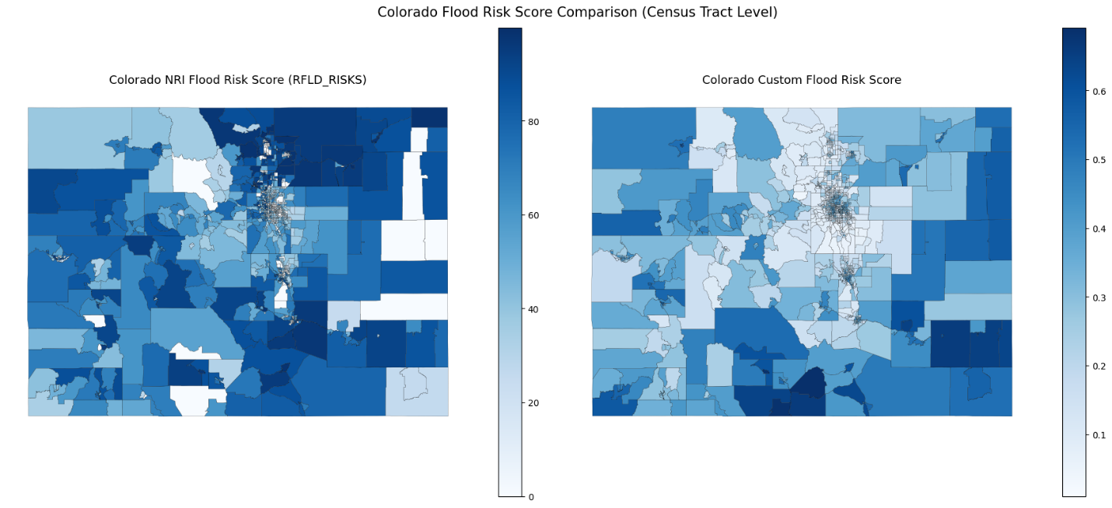
Figure 1: Colorado Flood Risk Scoring
The visual comparison reveals a significant spatial shift in risk scoring. The NRI figure (left) identifies the more eastern and urban population centers as the primary risk zone. This is largely driven by the high Expected Annual Loss (EAL). However, our Custom risk model (right) effectively redistributes the risk by applying a logarithmic transformation to EAL and a nonlinear penalty to resilience. Our new model identifies rural tracts in Southern and Eastern Colorado with an elevated risk. These lower property value areas exhibit a higher social vulnerability and a lower community resilience. The findings of this analysis highlight a “Capital Bias” within the NRI risk evaluations. The results suggest that the NRI may inadvertently prioritize wealthier urban centers for FEMA funding, potentially excluding more vulnerable rural communities under prepared for flood risk events.
The previous comparison focused on continuous risk scores; however, it is also important to examine how these differences are represented when risk is visualized using relative rankings, The following visualization displays the risk rankings of the NRI output and those derived from our team’s model
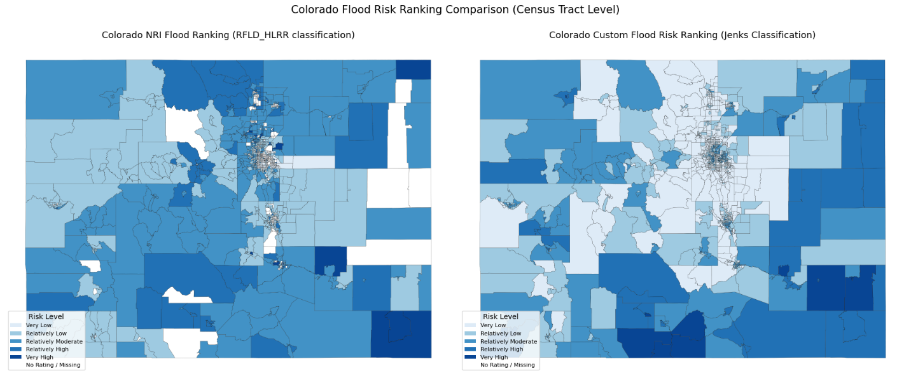
Figure 2: Colorado Flood Risk Ranking
After transitioning from continuous risk scores to a relative risk ranking the divergence between the two methodologies becomes even more evident, The NRI Flood Ranking (left) shows a distribution where the majority of the state is classified as 'Relatively Low' to 'Moderate,' with 'Very High' risk ranking almost entirely restricted to high value urban centers. In contrast, our team’s custom flood risk ranking (right) identifies a more geographically diverse distribution of risk ranking. Specifically, several rural census tracts in southern Colorado have an elevated risk classification. This shift is a direct result of our model’s emphasis on the lack of community resilience and higher social vulnerability. The sheer volume of the urban infrastructure outweighs the human vulnerability of less populated areas in the NRI risk models. Our model identifies a different set of priorities that would otherwise be overlooked.
To further evaluate the consistency of these findings our analysis now shifts to Texas to examine flood risk scores in a different geographic and environmental context allowing for a broader comparison of how both the NRI methodology and our team’s proposed model perform under varying conditions.
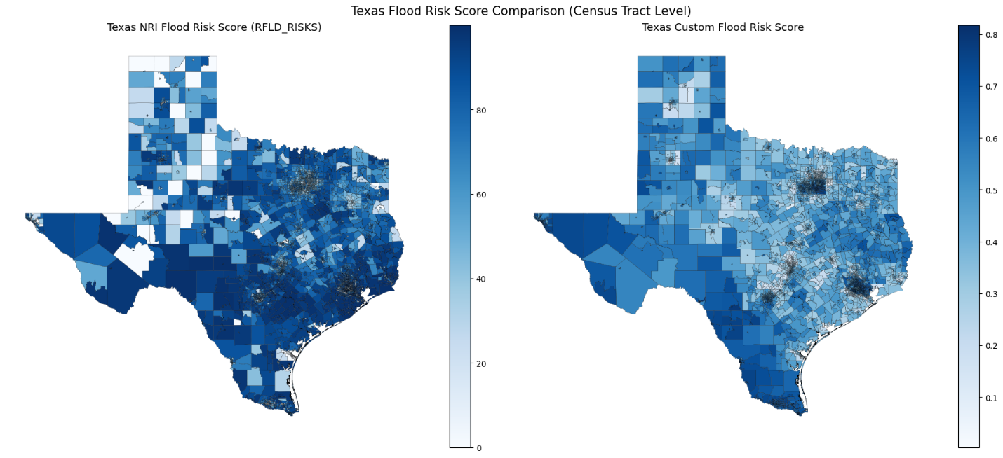
Figure 3: Texas Flood Risk Scoring
This analysis of Texas flood risk further illustrates the bias in property value modes. In the NRI methodology (left) the flood risk is again heavily concentrated in high density high value regions along the gulf, effectively masking the vulnerabilities of inland communities. Our model (right) provides a more equitable distribution of risk by dampening the influence of property values thought the logarithmic EAL transformation. This shift is most visible throughout western Texas, where scores increase significantly compared to the NRI model. In these regions, the high social vulnerability and lower community resilience are the primary factors of the risk. Factors that are frequently overlooked in the NRI calculation because of the economic magnitude oof the coastal urban centers. Again, we see NRI methodology represents a bias towards high value real estate. Our model suggests that a weighted approach may more accurately display communities that lack the infrastructure to bounce back from flooding events.
While the previous analysis highlighted the difference in absolute risk values, it is equally valuable to examine how these risk scores will translate into categorical classifications, The following figure provide further insight into how each methodology represents risk expressed in relative terms.
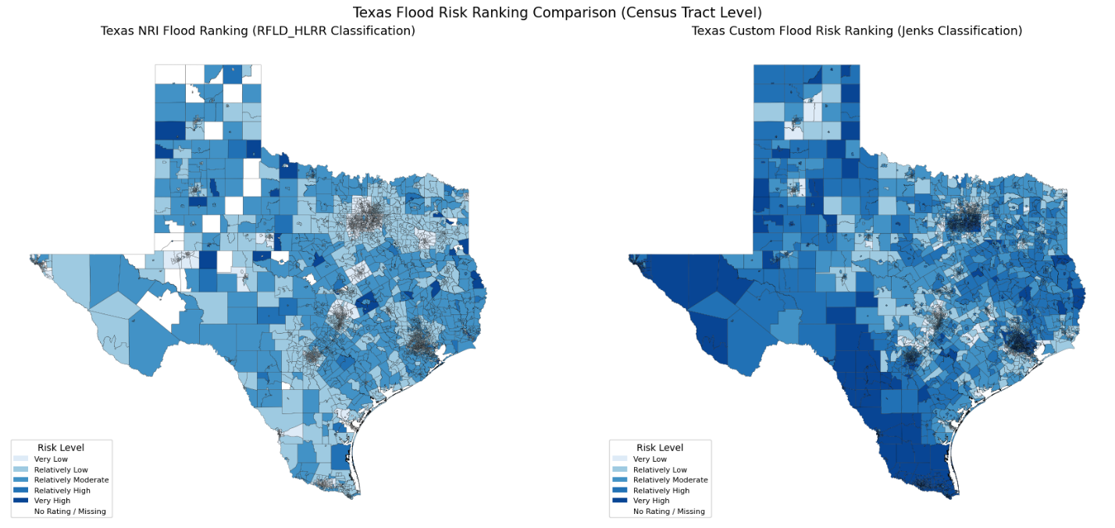
Figure 4: Texas Flood Risk Ranking
This categorical ranking visualization provides further evidence of capital bias withing the NRI methodology. The “Very High” risk category is almost entirely pinned to the eastern coastline while inland regions are tagged with “Relatively Low” or “Moderate” risk classifications despite facing significant flood risk. Our ranking formula incorporates weighted social vulnerability and a nonlinear resilience penalty which redefines the states risk distribution entirely. This is most notably apparent along the southern broader where the risk categories shift from “Relatively Low” to “Very High” risk. This shift effectively illustrates the NRI’s reliance on raw expected annual loss, creating a systematic bias against economically disadvantaged regions. By prioritizing potential capital losses over community risk. The NRI’s methodology may inadvertently cause these disadvantaged regions to be overlooked. Our team’s model identifies a more equitable distribution of risk that accounts for the fact that a loss in a low resilience community is often more catastrophic than a statistically larger loss in a high resilience urban center.
This analysis will now shift to wildfire risk beginning in Colorado. This transition allows for evaluation and testing to understand how each methodology performs under a different hazard type.
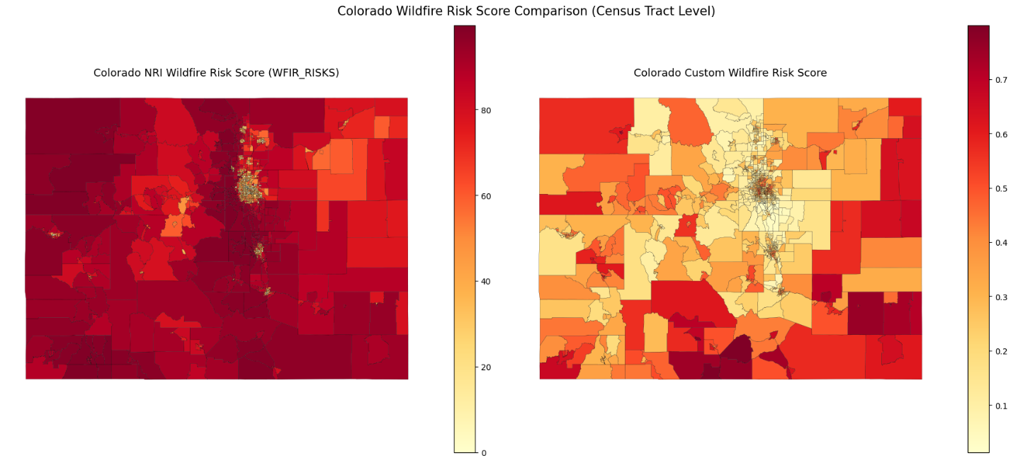
Figure 5: Colorado Wildfire Risk Scoring
This evaluation of wildfire risk in Colorado portrays a significant divergence in risk between the two methodologies. The NRI wildfire risk (left) displays a heavy risk saturation, classifying the large majority of the state as high risk. This uniformity makes it difficult to prioritize specific regions as it lacks the sensitivity to easily distinguish between varying levels of risk. Our team’s wildfire risk score calculation effectively deconsolidates this risk by applying the logarithmic dampening to EAL. This methodology prevents high exposure areas from automatically being classified as high risk. Our model reflects the interaction between social vulnerability and our resilience penalty which results in the lower risk areas as they are effectively “pockets of preparedness” In our model communities that have high levels of resilience are identifiable as low risk compared to areas with similar exposure. These findings suggest that the NRI methodology may be over penalizing resilient populations whereas our model is representative of the community’s readiness and resilience.
The score-based analysis effectively reveals differences in how wildfire risk is distributed. However, it is also important to consider how these distinctions change once translated into categorical rankings. The following figure presents the Colorado wildfire risk ranking.
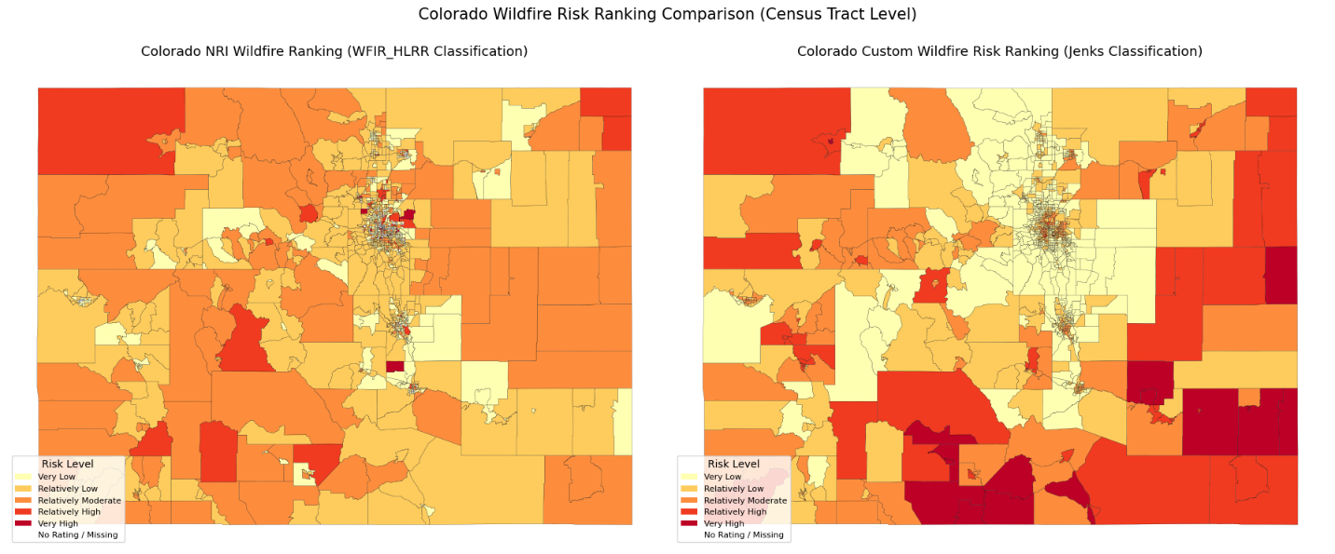
Figure 6: Colorado Wildfire Risk Ranking
The categorical ranking of Colorado wildfire risk further displays the more practical usability of our proposed model over the NRI framework. The NRI output (left) demonstrates a lack of statistical spread, causing the majority of census tracts falling into the “Relatively High” category. This flattened risk profile provides limited guidance for resource allocation. Our custom risk profile is able to maximize the variance between risk tiers. This methodology effectively identifies risk extremes that are nuanced by the NRI. Most notably our risk model identifies several mountain communities as very low/relatively low, compared to the NRI classification of high. This shift in classification is attributed to our resilience penalty. Our methodology is able to recognize the high community preparedness can mitigate high hazard exposure. Conversely, many areas in the south are elevated to a high-risk categorization. The elevated risk classification displays a curtail intersection of low resilience and high vulnerability. These results prove that the NRI methodology suffers from an exposure bias that overlooks a community’s resilience.
To further assess wildfire risk patterns, the analysis shifts to Texas. Evaluating wildfire risk across a new geographic context will provide additional comparison between methodologies,
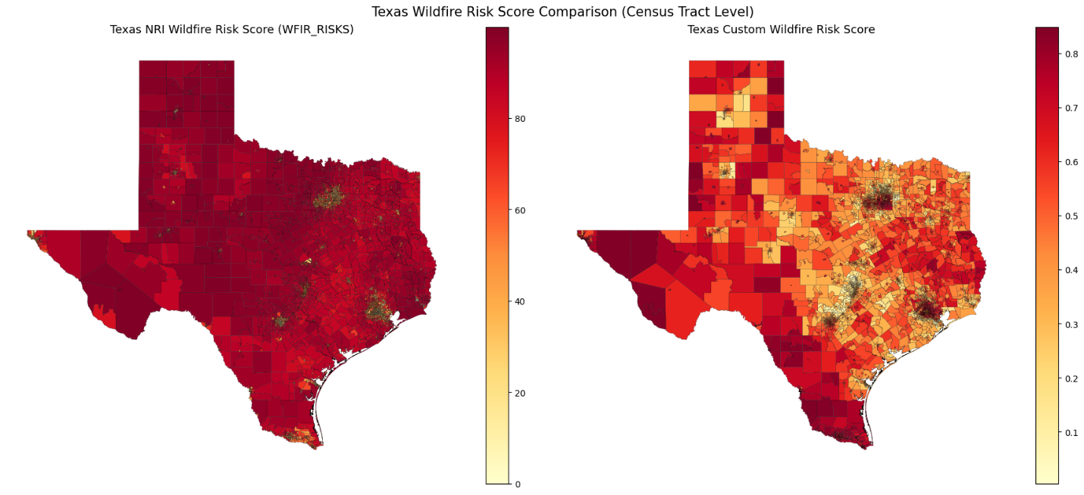
Figure 7: Texas Wildfire Risk Scoring
The analysis of wildfire risk in Texas further reinforces the findings from the Colorado study. Again, the NRI wildfire risk score map (left) presents nearly uniform distribution of extreme risk across the region despite that significant variance in socioeconomic status. This lack of distribution limits the NRI’s utility as a tool for emergency management. Our team’s wildfire risk score (right) is able to provide a much-needed correction to this distribution. By dampening the influence of EAL, our model is able to recognize specific vulnerable corridors. The Rio Grande Valley and West Texas notably emerge as high-risk zones. This comparison is vital. It effectively shows how the NRI’s bias can treat risk as a commodity based on property loss compared to our model that treats risk as a measure of human/community fragility.
To further support these findings, it is necessary to examine how the observed difference is reflected in categorical rankings. The following figure presents the Texas wildfire risk rankings, Providing additional insight.
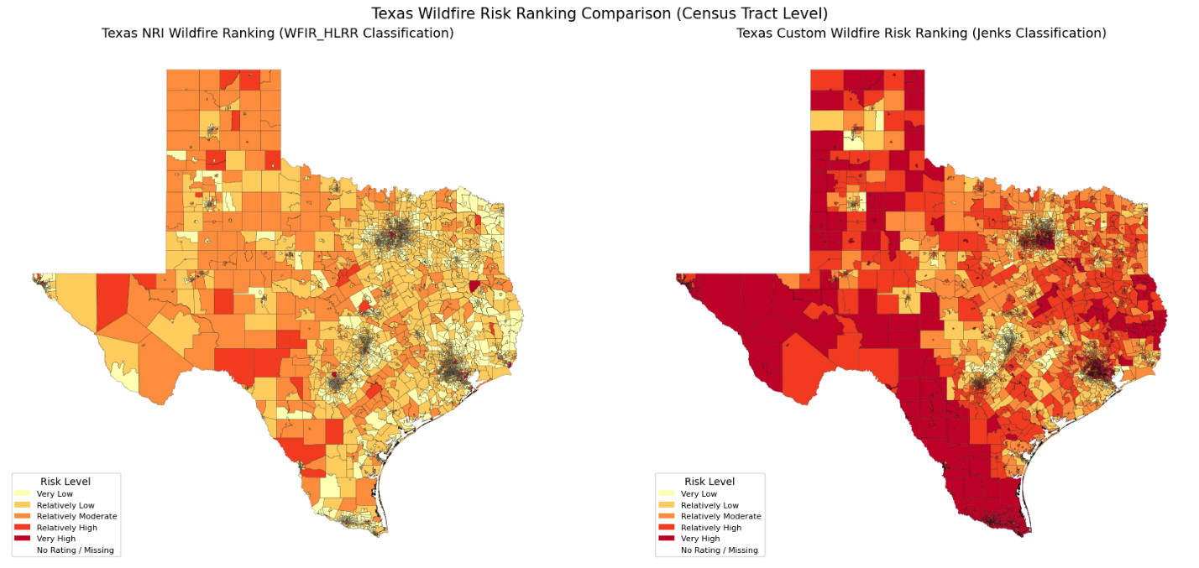
Figure 8: Texas Wildfire Risk Ranking
The categorical ranking of wildfire risk in Texas provides a definitive look at the risk of bias in risk definition. The NRI ranking (left) fails to provide clear prioritization, spreading moderate and high rankings across the state. Our risk ranking (right) is able to reorganize states risk priorities. Our model identifies the Rio Grande valley and the Texas Panhandle as “Very High” risk zone, areas that the NRI classifies as significantly lower risk comparatively. This shift exposes a wealth bias in the federal methodology. Because the NRI’s rankings are heavily influenced by property value, it underestimates the threat to communities with low social vulnerability. Our model proves that when risk is defined by a community’s ability to withstand and recover from a natural disaster, the list of “priority communities” changes entirely.
The previous comparisons focused on spatial patterns and categorical rankings. This analysis will now shift to observe how each methodology performed at the extreme end of the distribution. The following summary chart presents the top 10 highest risk Census tracts for wildfire in both Colorado and Texas, using a standardized 0-100 scale to directly compare NRI scores with our team’s proposed model outputs.
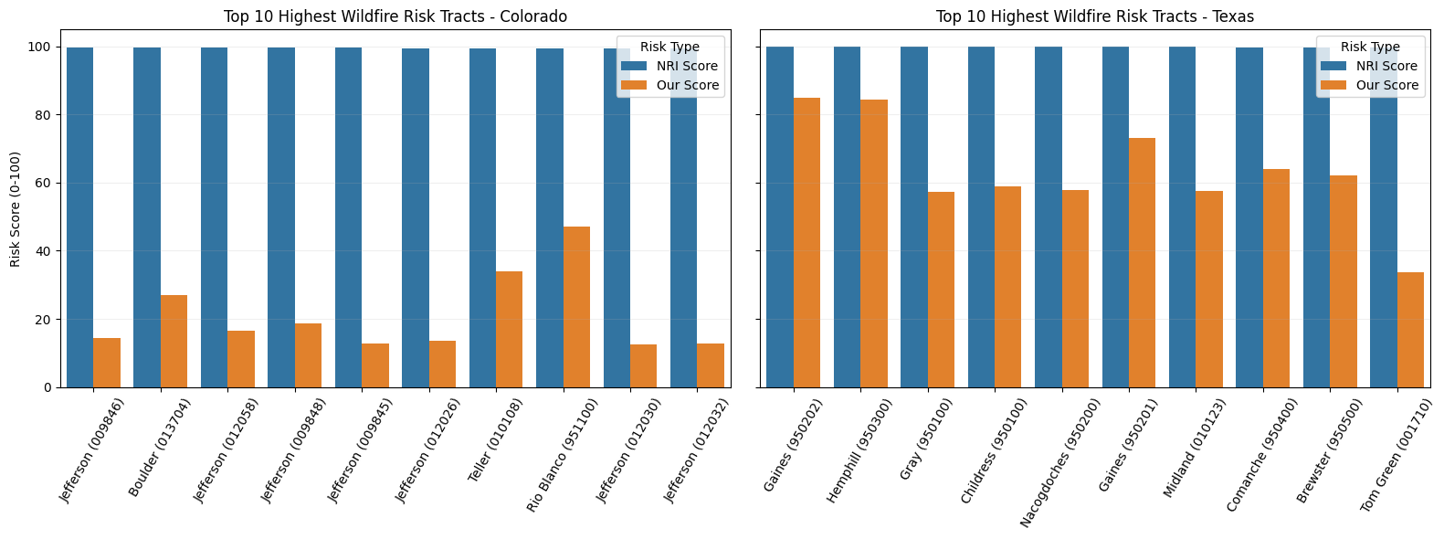
Figure 9: Wildfire NRI vs Alternative Risk Definition
The Top 10 highest ranked wildfire tracts in each state illustrate a clear saturation bias withing the NRI framework. Every top tier tract is assigned to the maximum score of 100. This lack of differentiation creates a sort of paralysis for emergency management as the NRI is unable to provide any sort of statistical basis for selecting between high-risk areas. Our custom model effectively adjusted these extremes. In Colorado, many tracts that the NRI rated as 100 were adjusted to scores below 20. The lower scores are representative of that areas robust community resilience, factors the NRI fails to weight appropriately. In Texas, the top 10 tracts remained significantly higher in our custom model (ranging from 40 to 80). This indicates that our model is able to identify these Texas tracts as having a more susceptible combination of social vulnerability and infrastructure deficits. These charts serve as quantitative proof of concept by dampening property value influence and emphasizing human factors.
A similar comparison is conducted for flood risk, allowing for evaluation of whether the observed saturation effects and distributional differences persist across hazard types. The flowing chart presents the top 10 highest risk census tracts for flood risk in Colorado and Texas, again comparing NRI scores with the proposed model.
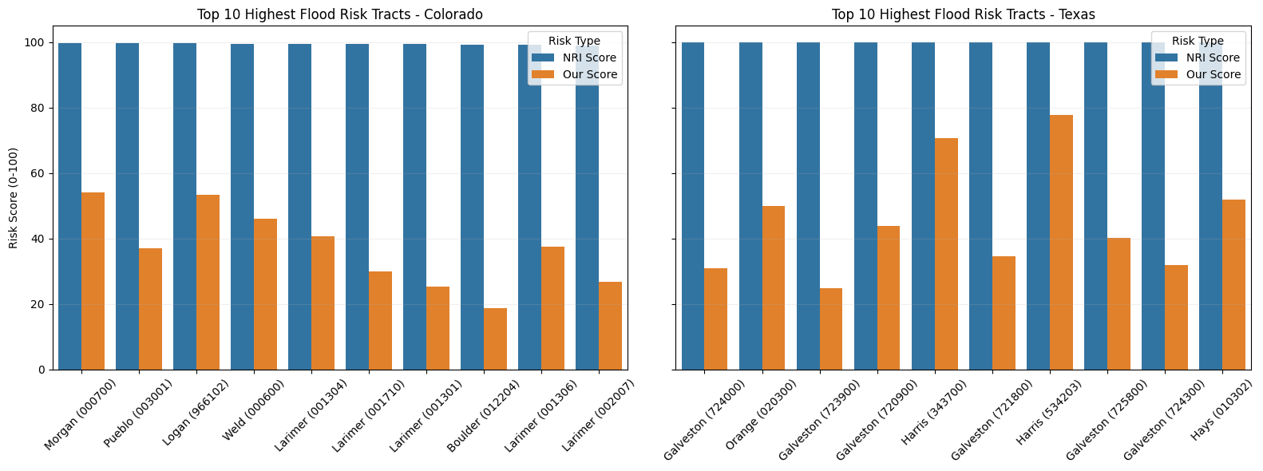
Figure 10: Flood NRI vs Alternative Risk Definition
The quantitative analysis of the Top 10 Flood Risk tracts confirms that the saturation bias observed in wildfire data persists across hazard types. In both Colorado and Texas, the NRI produces a unform score of 100 across all tracts, effectively masking the variation in vulnerability. Our model provides a crucial corrective lens. In Colorado, we see that rural tracts such as Morgan County carry a higher risk than value tracts in Boulder once social factors are weighted appropriately. Our model is able to distinguish between high exposure coastal regions (Galveston) and high vulnerability urban areas (Harris), revealing that resilience infrastructure in Galveston successfully mitigates a portion of the raw hazard exposure. These results prove that the NRI disproportionally weights potential economic loss compared to potential community damage. Our model ensures that all factors are considered to ensure that mitigation dollars are targeted towards the communities where human impacts would be most devastating rather than where the property values are highest.

Conclusion
This study evaluated the effectiveness of the Federal Emergency Management Agency’s (FEMA) National Risk Index (NRI) by comparing its risk calculations to an alternative risk model design by our team of professionals to more heavily incorporate social vulnerability and community resilience. Through a comprehensive statical and spatial analysis of flood and wildfire risk across Colorado and Texas, consistent differences emerged between the two methodologies. The results indicate that the NRI framework is exceedingly influenced by Expected Annual Loss (EAL) which is closely tied to property value and economic exposure. As a result, the NRI’s risk calculation tends to concentrate high risk classifications in urban and high value regions, while underrepresenting risk in rural and economically disadvantaged communities. This pattern was observed across both hazard types and across different forms of analysis, including continuous risk scores, categorical ranking, and extreme value comparison. Our team’s proposed model demonstrated a more balanced distribution of risk by reducing the dominate of economic loss through a logarithmic scaling approach while also incorporating a nonlinear penalty for reduced community resilience. This difference in methodology allowed for the identification of high-risk areas that are not necessarily defined by high property value, but rather by a limited capacity to prepare for, respond to, and recover from natural disasters. As a result, multiple communities in regions such as southern Colorado, Western Texas, and the Rio Grande Valley were more consistently identified as high risk under our proposed framework. These findings suggest that the existing NRI methodology may introduce a form of “capital bias”. This causes the risk to be implicitly tied to the value of physical assets rather than the vulnerability of affected populations. This has important implications for the allocation of federal resources for disaster aid, as the reliance on property-based risk metrics may lead to the prioritization of economically dense areas over communities that have a greater social need. Ultimately, this analysis demonstrates that how risk is defined has a direct impact on potential funding priorities. By incorporating social vulnerability and resilience more explicitly into risk calculations, like our proposed alternative model, it creates a more equitable and actionable framework for identifying at risk populations.

References
Federal Emergency Management Agency. (2023). National Risk Index for natural hazards. U.S. Department of Homeland Security. https://www.fema.gov/national-risk-index
NOAA Office for Coastal Management. (2025). National Risk Index for natural hazards. National Oceanic and Atmospheric Administration. https://coast.noaa.gov/digitalcoast/tools/fema-hazards.html
Centers for Disease Control and Prevention & Agency for Toxic Substances and Disease Registry. (2024). Social Vulnerability Index. https://www.atsdr.cdc.gov/place-health/php/svi/index.html

Federal Emergency Management Agency. (2025). National Risk Index data methodology and hazards overview. U.S. Department of Homeland Security.
https://www.fema.gov/sites/default/files/documents/fema_national-risk-index_methodology-hazards-overview.pdf

